**ASSIGNMENT: 1**

**CREATE DATABASE:**



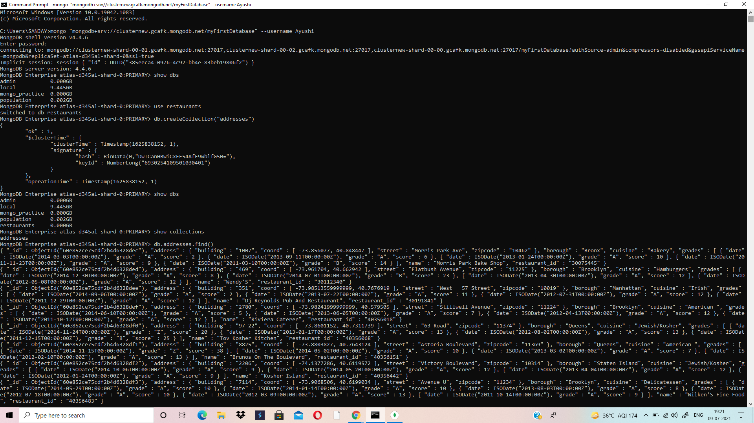

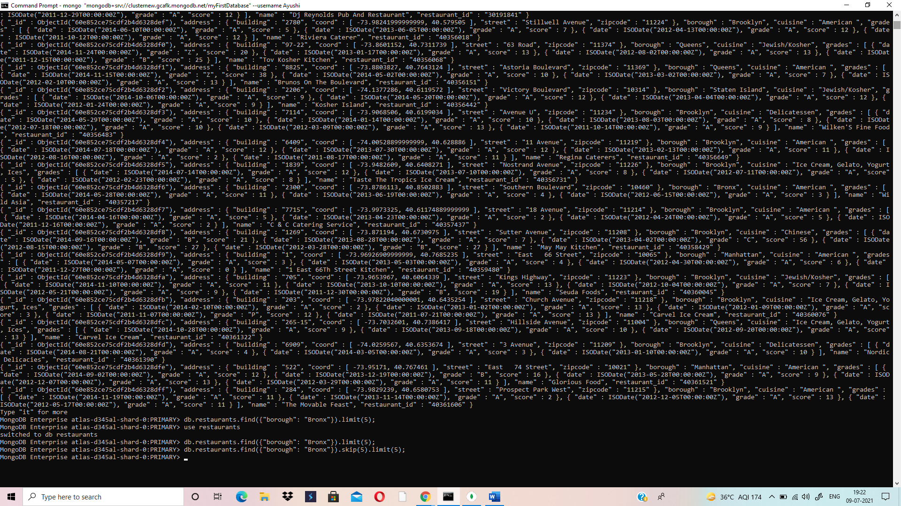

**JSON FILE DATA INSIDE COLLECTION OF THE DATABASE**

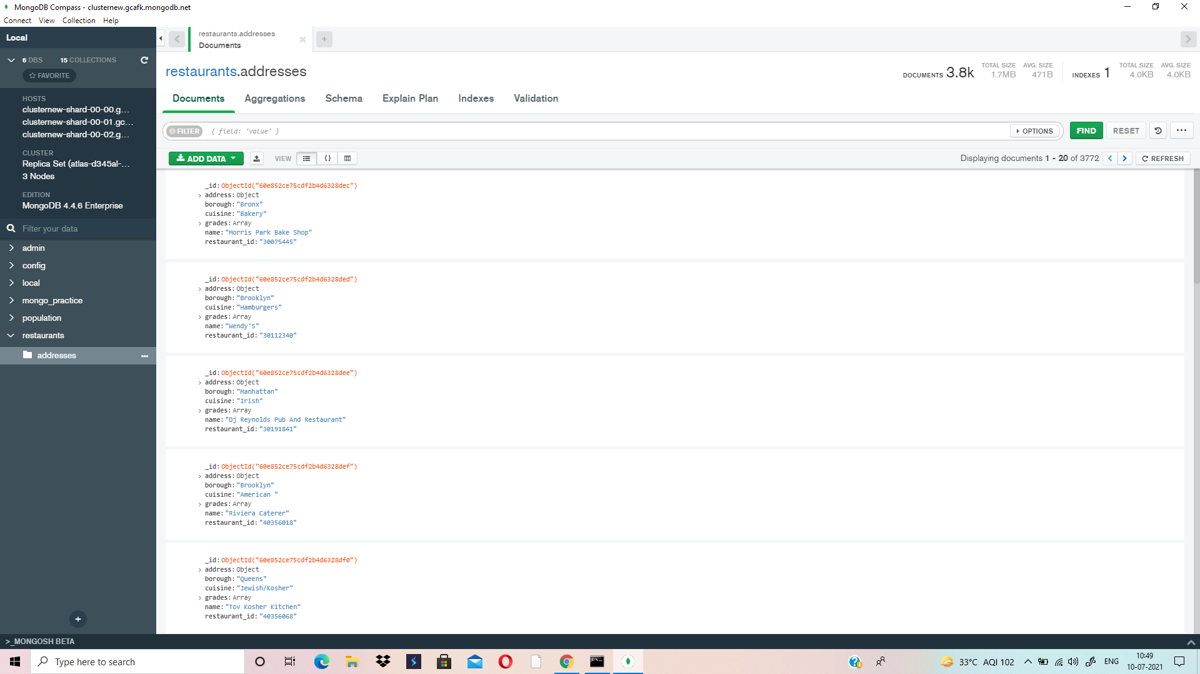

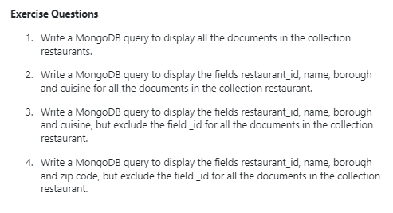

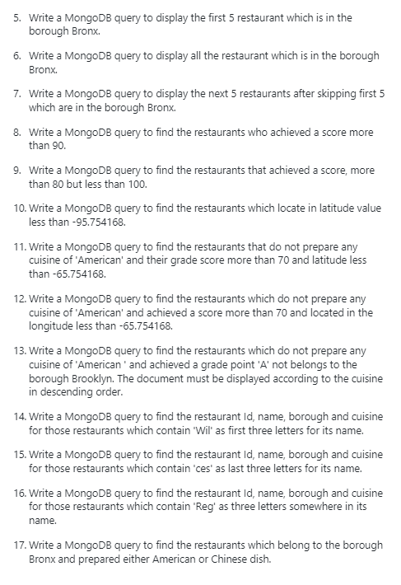

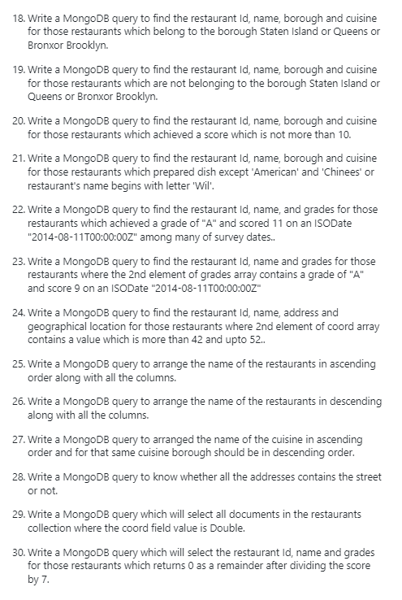



1) **db.addresses.find()**

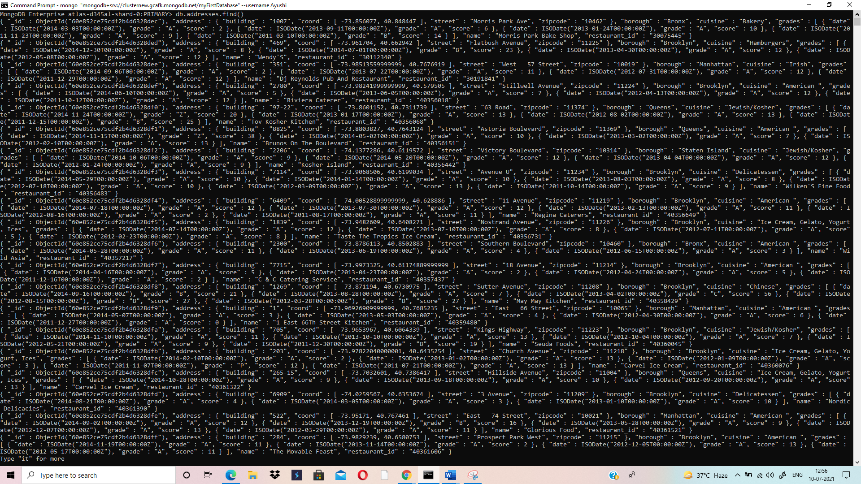

2) **db.addresses.find({},{restaurant_id:1,name:1,borough:1,cuisine:1})**

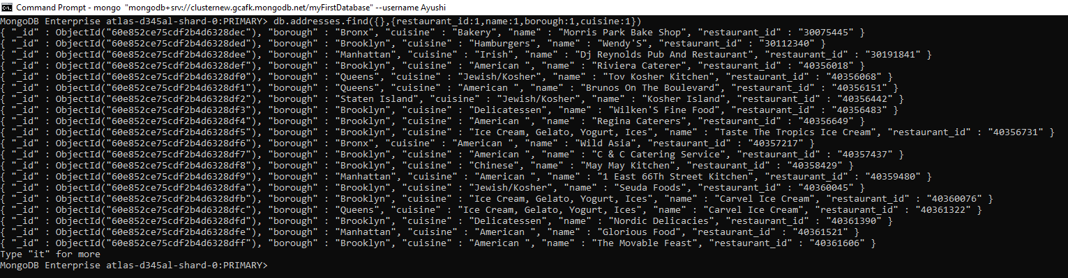

3) **db.addresses.find({},{restaurant_id:1,name:1,borough:1,cuisine:1,_id:0})**

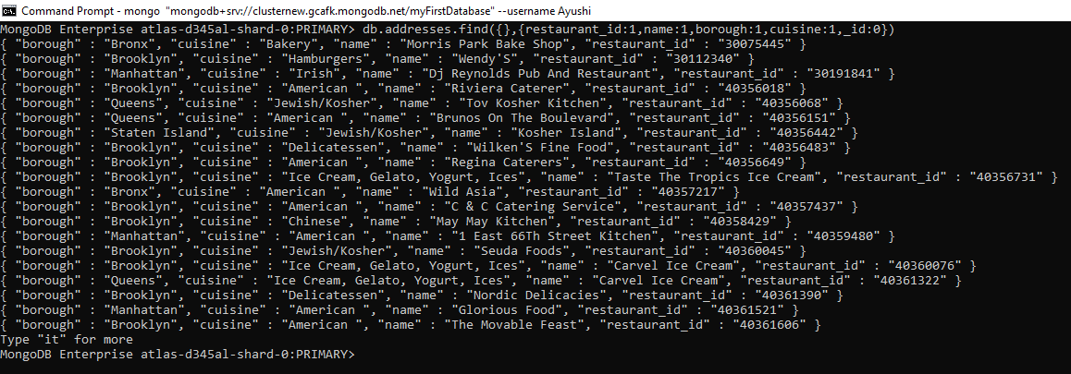

4) **db.addresses.find({},{"restaurant_id":1,"name":1,"borough":1,"address.zipcode":1,"_id":0})**

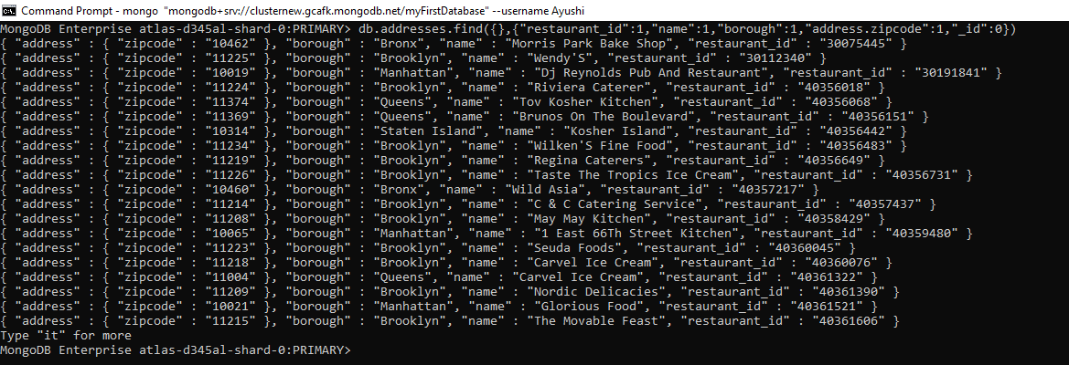

5) **db.addresses.find({"borough": "Bronx"}).limit(5);**

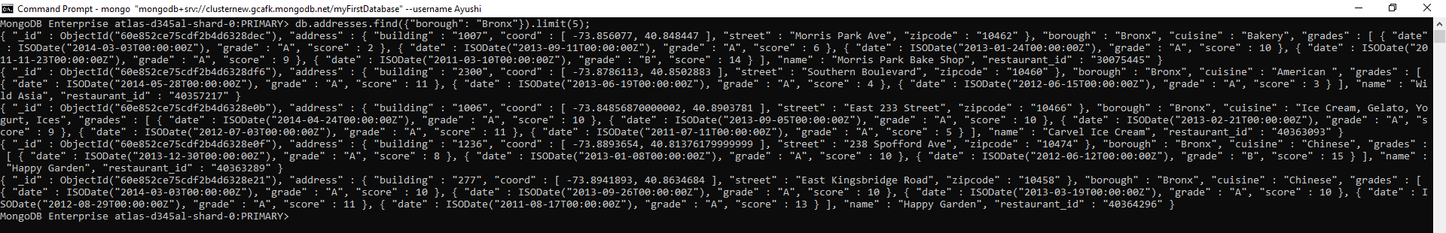

6) **db.addresses.find({"borough": "Bronx"})**

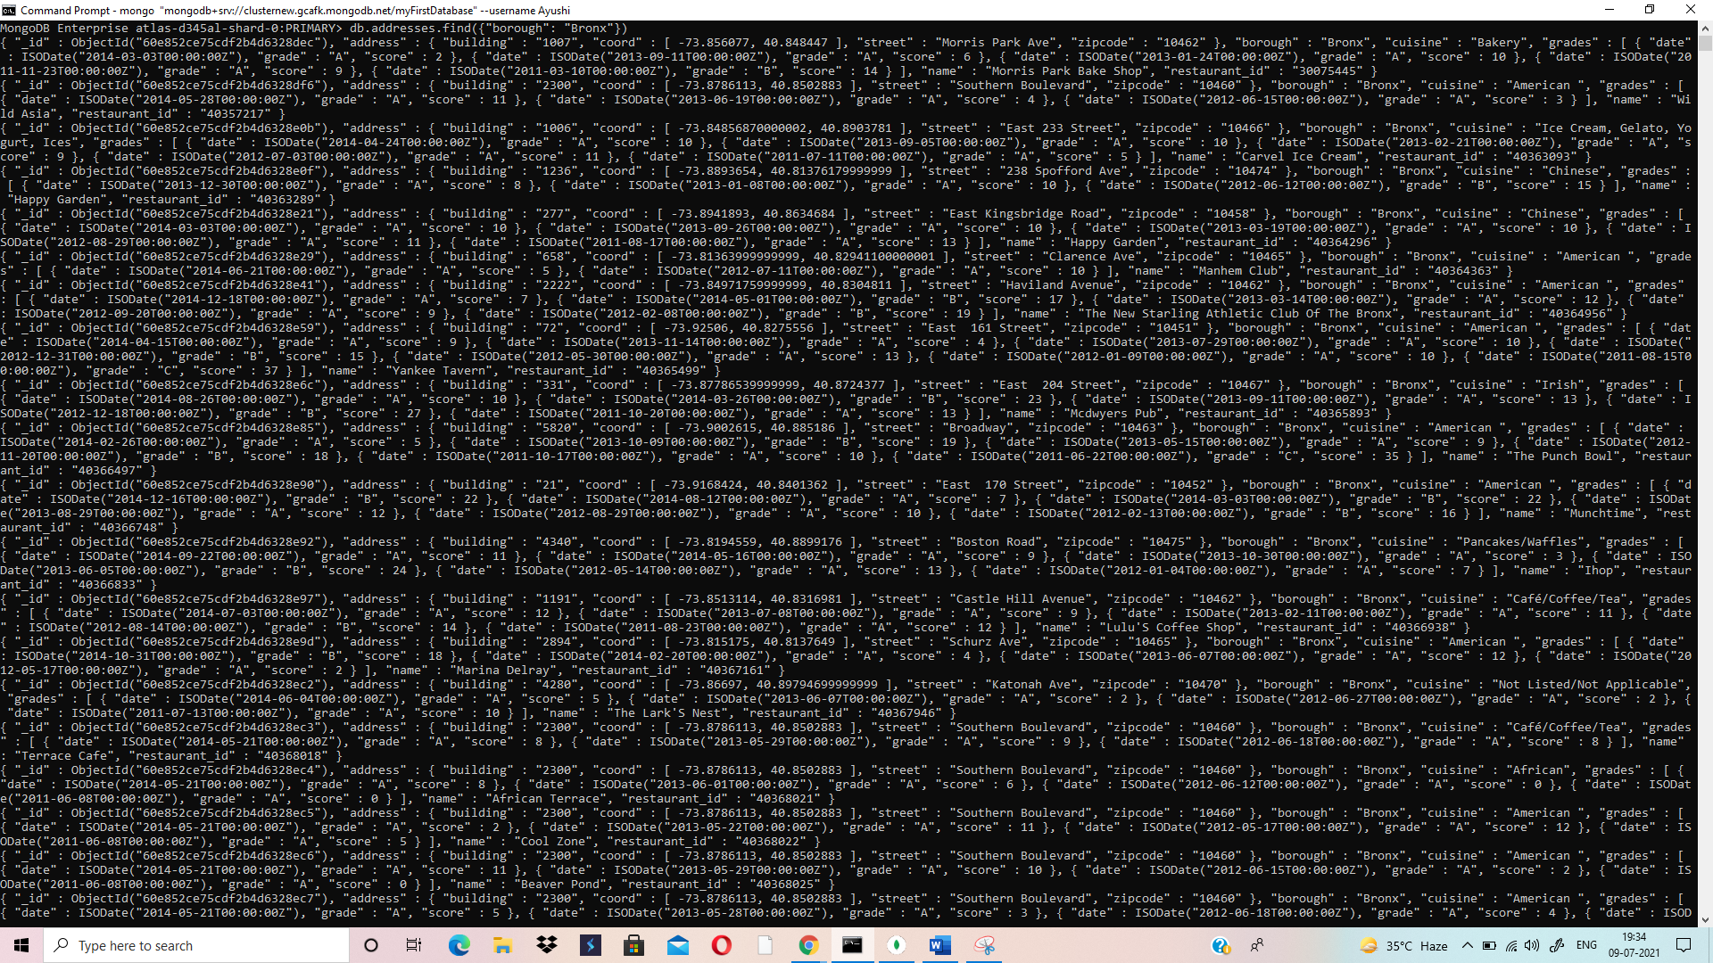

7) **db.addresses.find({"borough": "Bronx"}).skip(5).limit(5);**

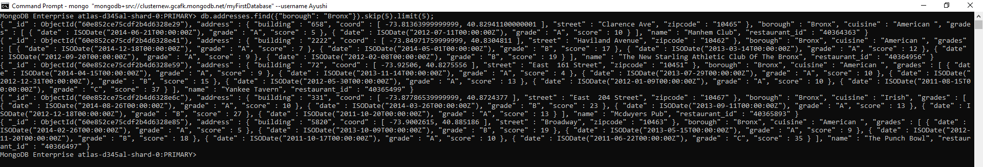

8) **db.addresses.find({"score": {$gt:90}})**

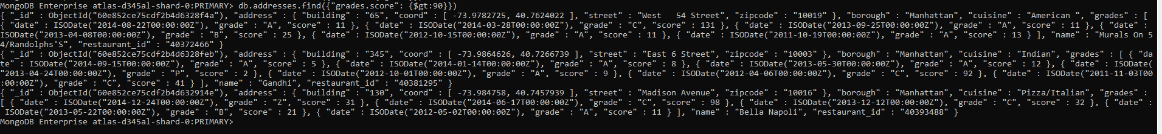

9) **db.addresses.find({"grades.score":{$gt:90,$lt:100}})**

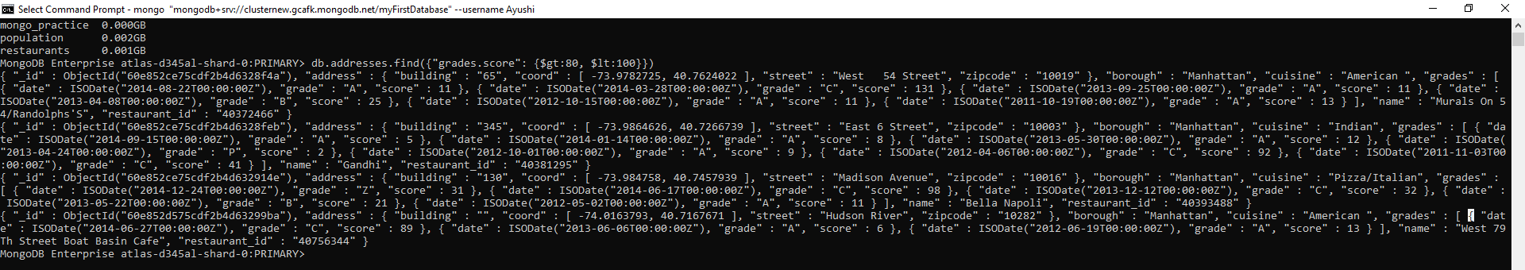

10) **db.addresses.find({"address.coord.0" : {$lt : -95.754168}})**

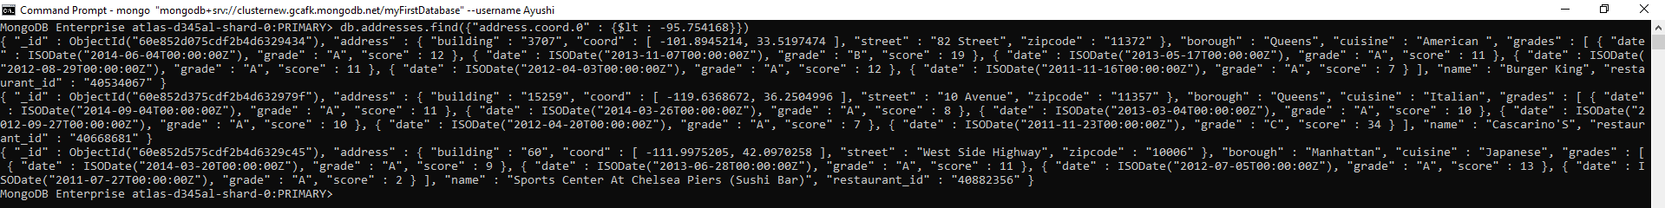

11) **db.addresses.find({$and:[{"cuisine" : {$ne :"American "}},{"grades.score" : {$gt : 70}},{"address.coord.0" : {$lt : -65.754168}}]})**

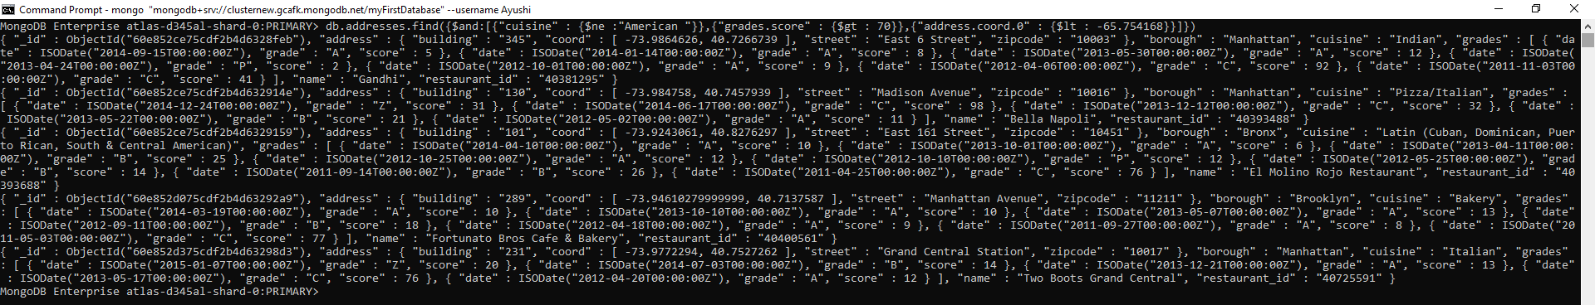

12) **db.addresses.find({$and : [{"cuisine" : {$ne : "American "}}, {"address.coord.1" : {$lt : -65.754168}}, {"grades.score" : {$gt : 70}}]})**



13) **db.addresses.find({$and : [{"cuisine" : {$ne : "American "}}, {"grades.grade" : "A"}, {"borough" : {$ne : "Brooklyn "}}]}).sort({cuisine : -1})**

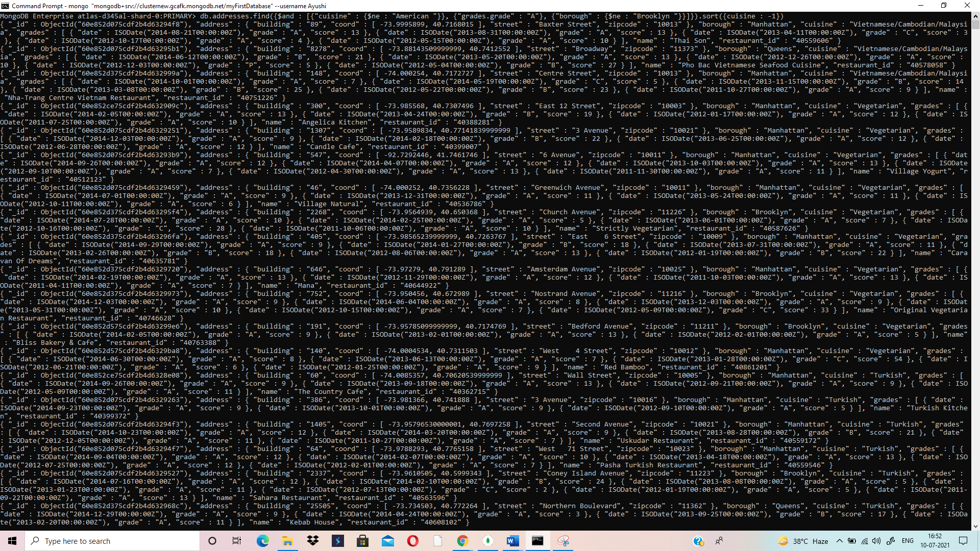

14) **db.addresses.find({name:/^Wil/},{restaurant_id:1,name:1,borough:1,cuisine:1})**



15) **db.addresses.find({name:/ces$/},{restaurant_id:1,name:1,borough:1,cuisine:1})**

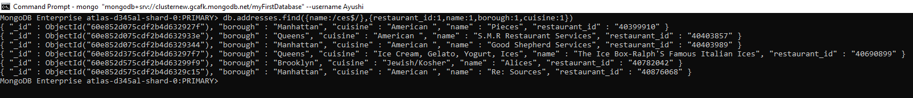

16) **db.addresses.find({name:/.*Reg.*/},{restaurant_id:1,name:1,borough:1,cuisine:1})**

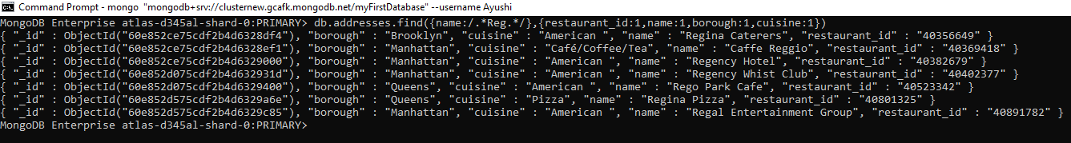

**17) db.addresses.find({borough:"Bronx",$or:[{cuisine:"American"},{cuisine:"Chinese"}]})**

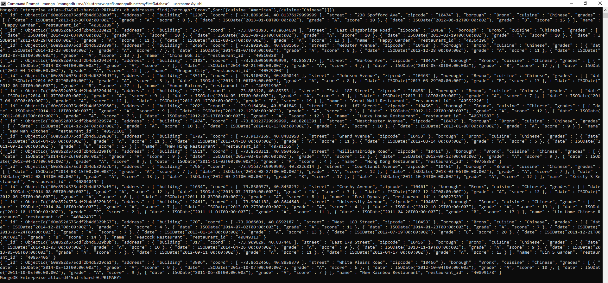

18) **db.addresses.find({$or:[{borough:"Staten Island"},{borough:"Queens"},{borough:"Bronx"},{borough:"Brooklyn"}]},{restaurant_id:1,name:1,borough:1,cuisine:1})**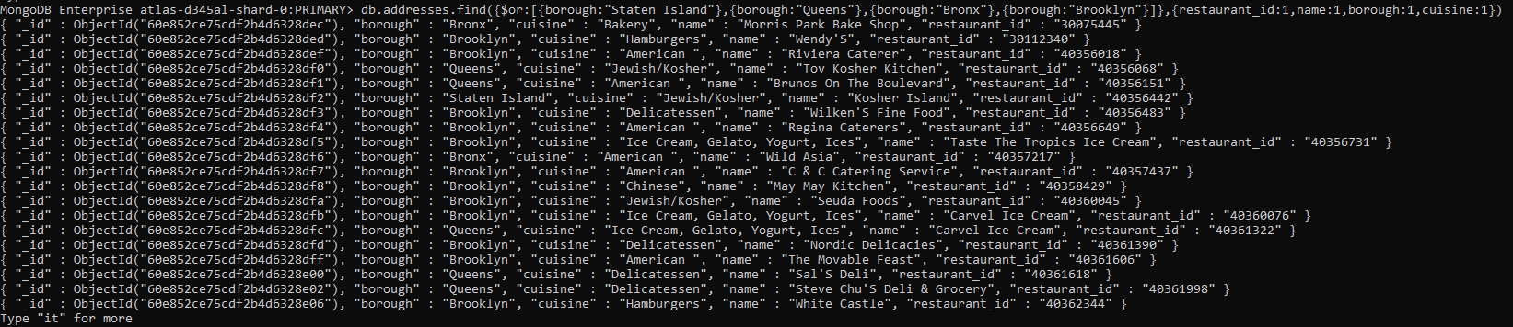

19) **db.addresses.find( {borough: {$nin: ["Staten Island","Queens","Bronx","Brooklyn"]}} , {_id:1, restaurant_id:1, name:1, borough:1, cuisine:1})**

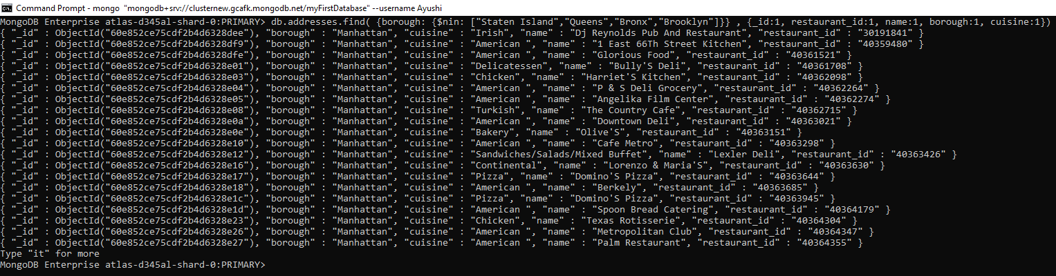

**20) db.addresses.find({"grades.score": {$lte: 10}}, {_id:0, restaurant_id:1, name:1, borough:1, cuisine:1})**

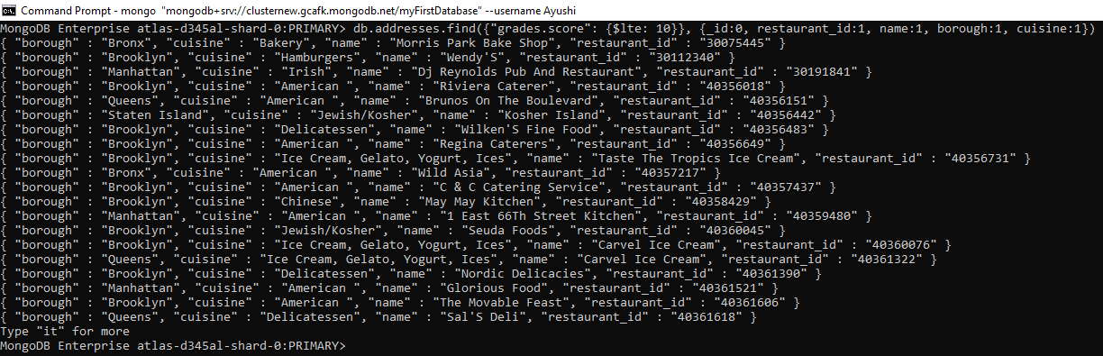

**21) db.addresses.find({$or:[{name:/^Wil/},{$and:[{cuisine:{$ne :"American "}},{cuisine:{$ne :"Chinees"}}]}]},{restaurant_id:1,name:1,borough:1,cuisine:1})**

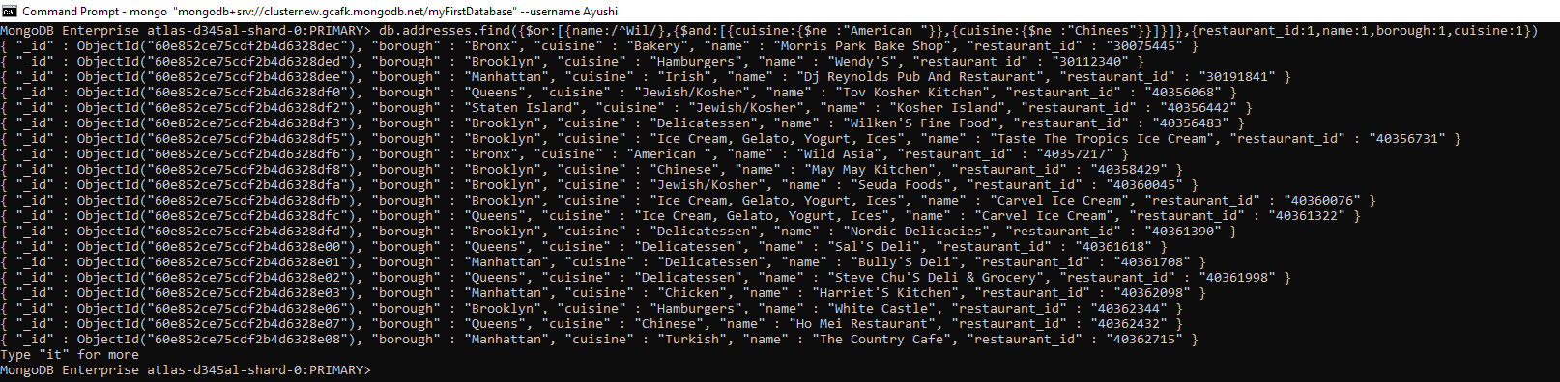

**22) db.addresses.find({"grades.grade":"A","grades.score":11,"grades.date":ISODate('2014-08-11T00:00:00Z')}, {restaurant_id:1,name:1,grades:1})**

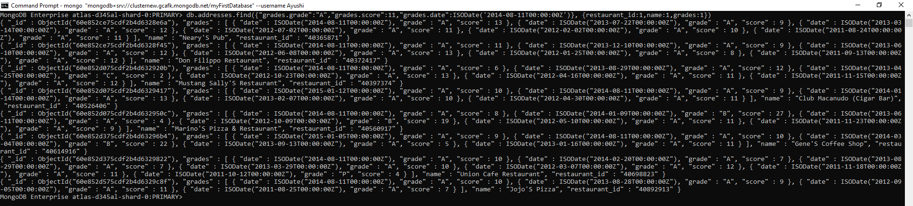

**23)** **db.addresses.find({$and: [{"grades.1.grade":"A"}, {"grades.1.score": 9}, {"grades.1.date": ISODate("2014-08-11T00:00:00Z")}]},{_id:1, restaurant_id:1, name:1, grades:1})**



**24) db.addresses.find({$and:[{"address.coord.1":{$gt:42}},{"address.coord.1":{$lte:52}}]},{restaurant_id:1,name:1,"address":1})**

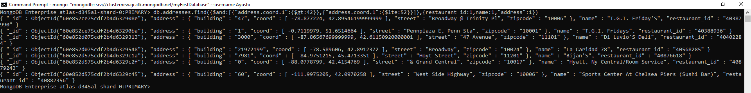

**25) db.addresses.find().sort({name:1})**

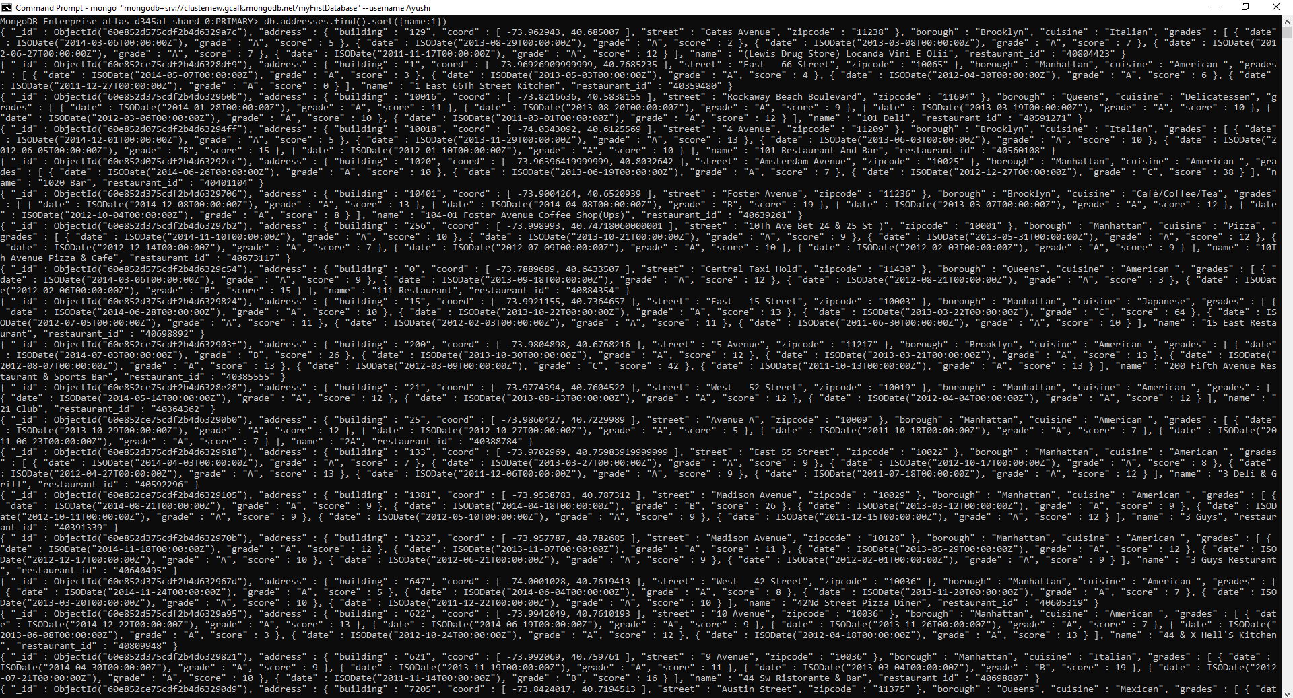

**26) db.addresses.find().sort({name:-1})**

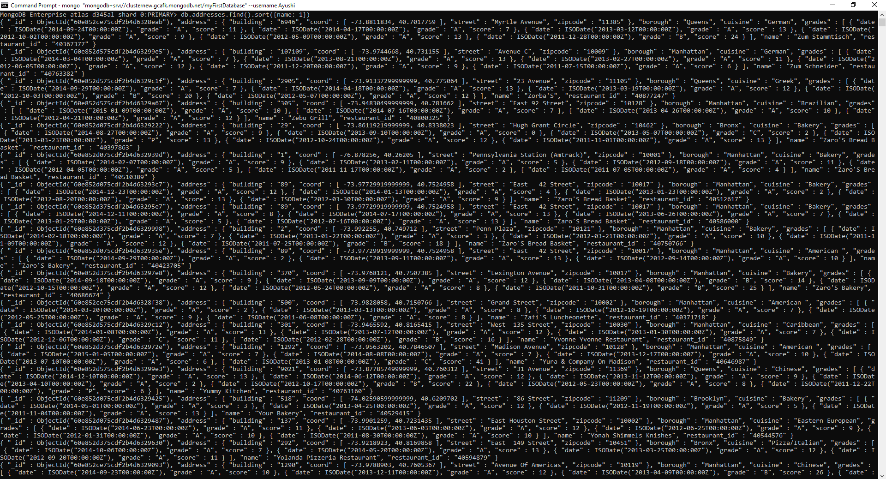

**27) db.addresses.find().sort({cuisine:1,borough:-1})**

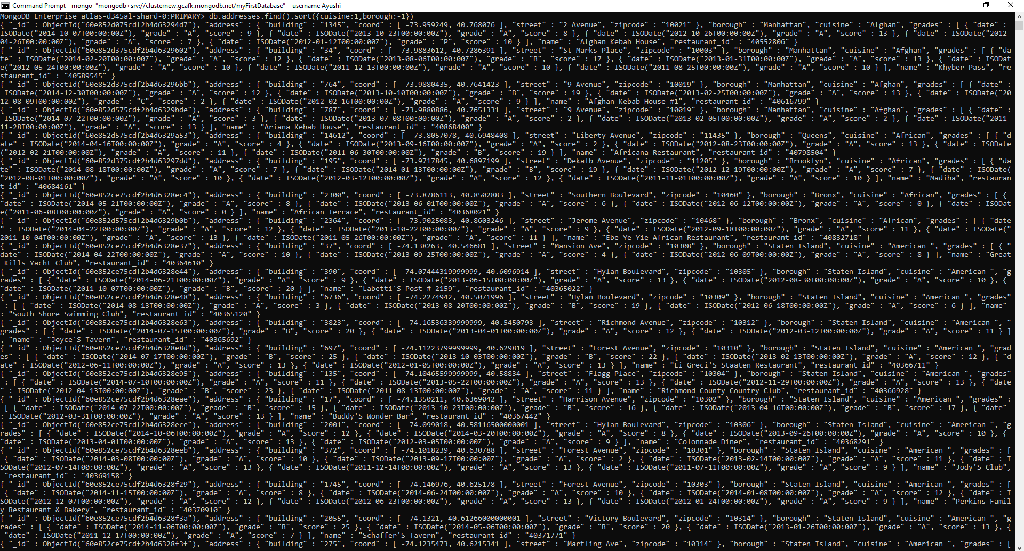

**28) db.addresses.find({"address.street":{$exists:true}})**

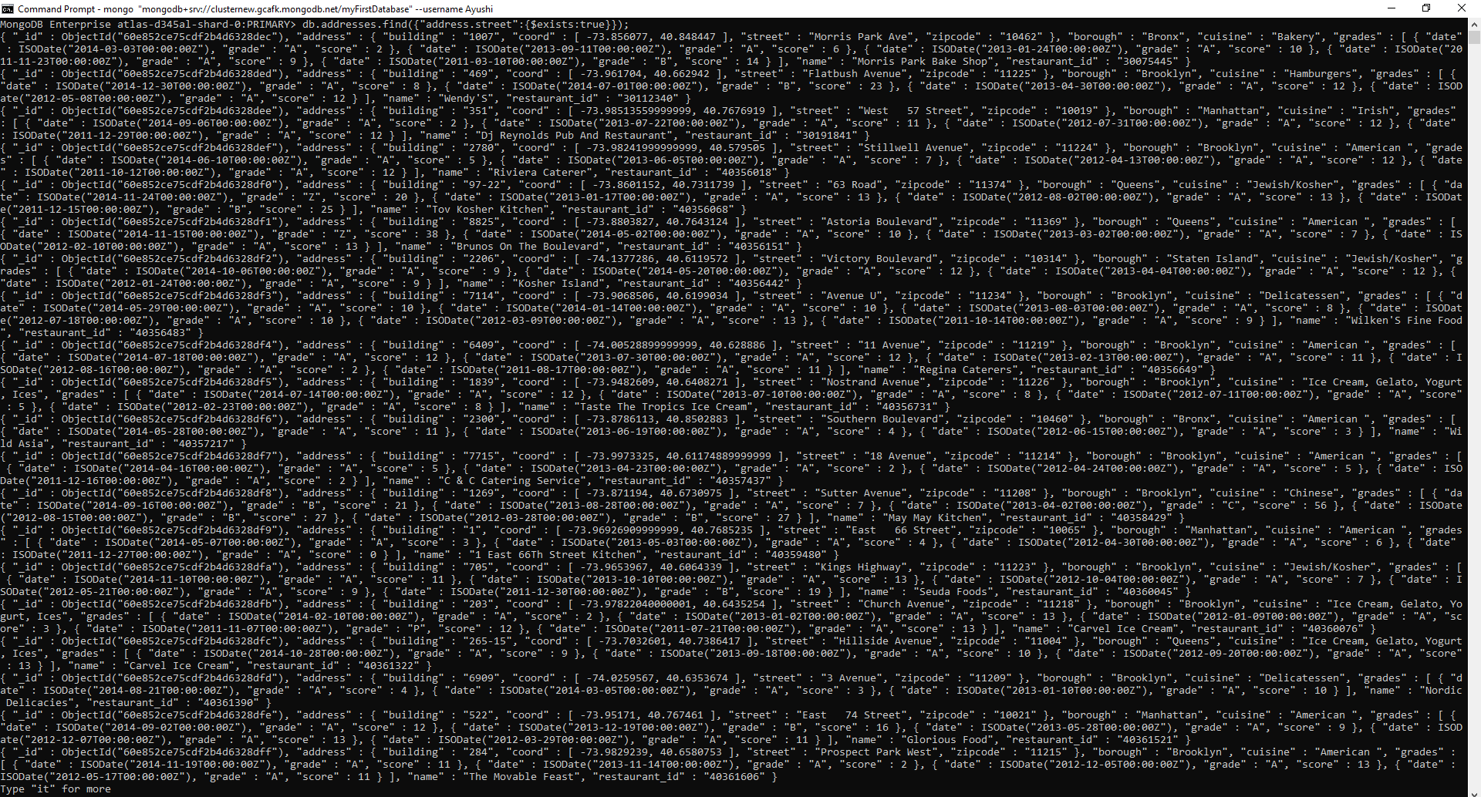

**29) db.addresses.find({"address.coord":{$type:1}})**

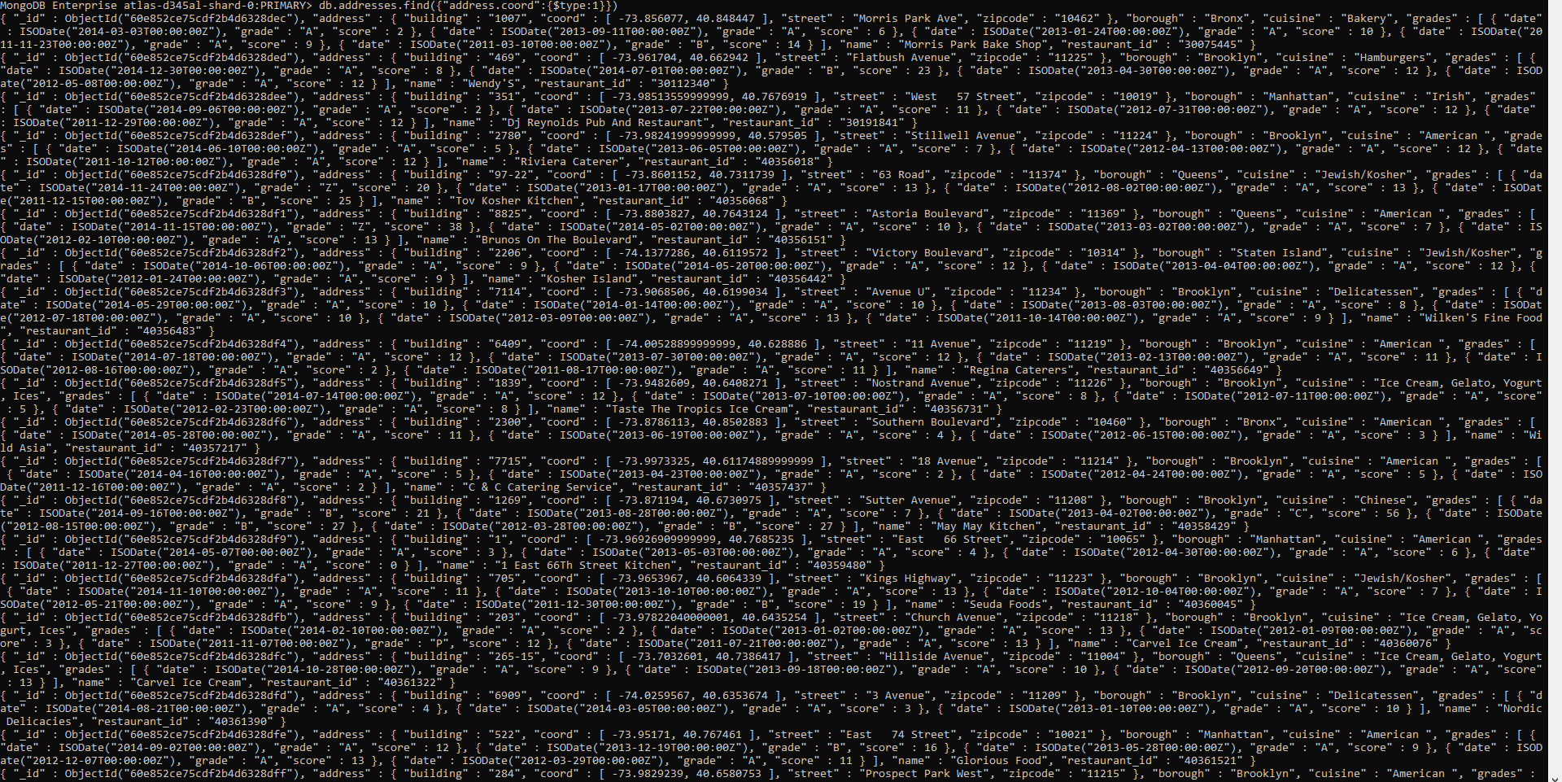

**30) db.addresses.find({"grades.score":{$mod:[7,0]}}, {restaurant_id:1,name:1,grades:1})**

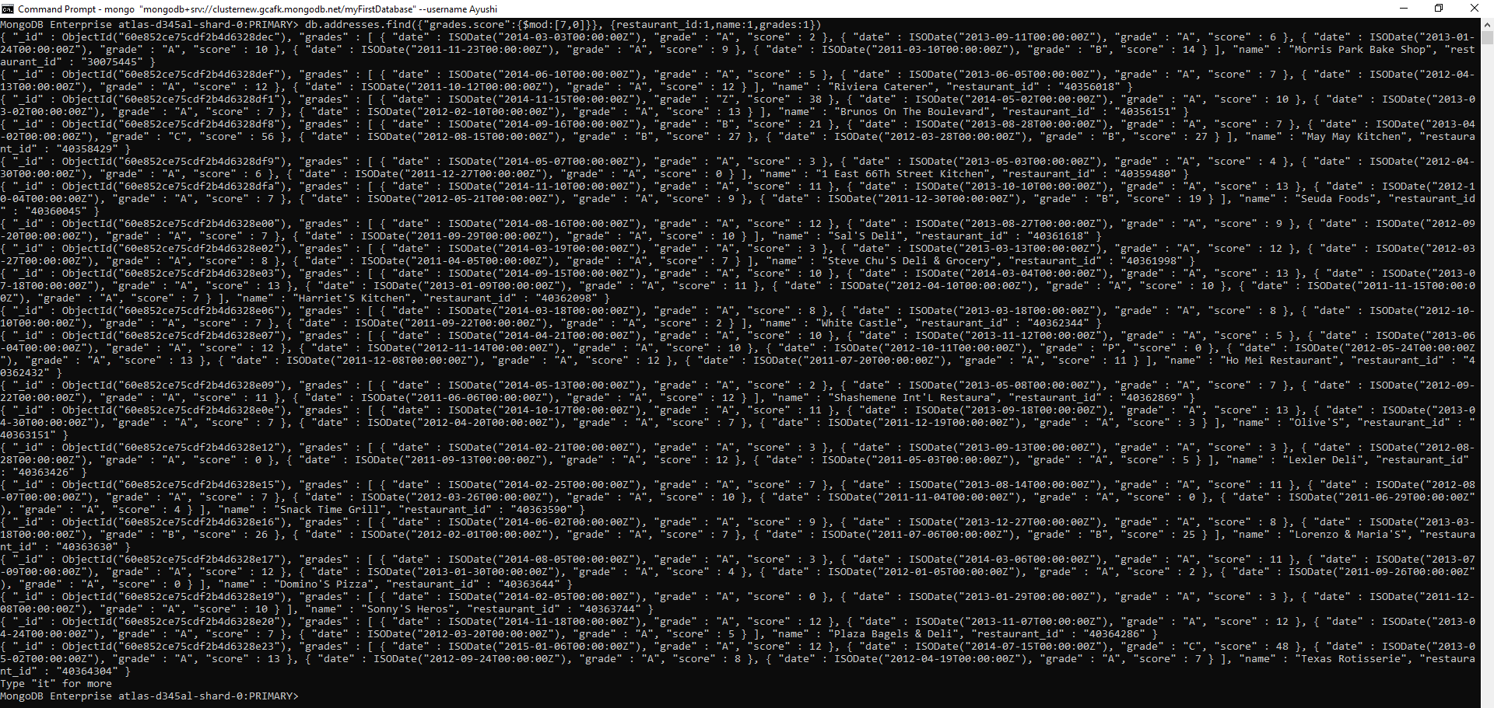

**31) db.addresses.find({name:/.*mon.*/}, {name:1,borough:1,cuisine:1,"address.coord":1})**

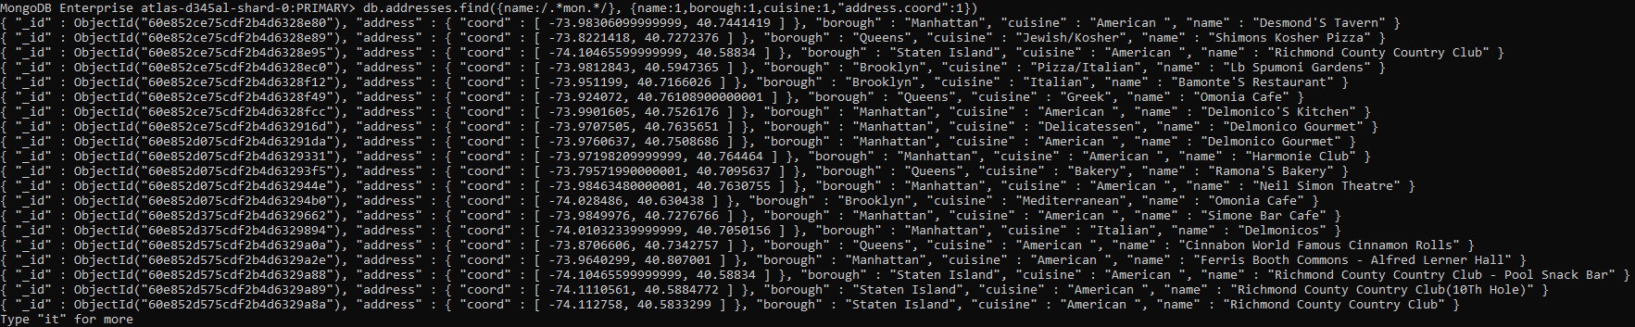

**32) db.addresses.find({name:/^Mad/}, {name:1,borough:1,cuisine:1,"address.coord":1})**

